# GATHERING PROJECT INFORMATION for 91899

***You should be aiming to write between 800 - 1500 words total***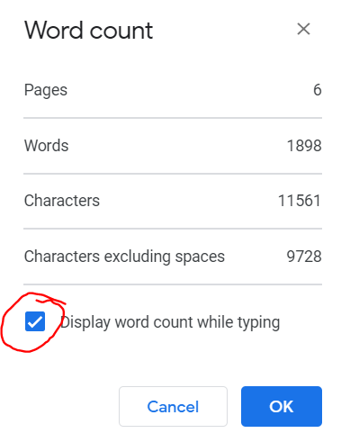

*to word count - highlight your paragraph and* ***CTRL + SHIFT + C***

*OR*

*Go to Tools → Word Count and tick the ‘Display word count while typing box’. You will then see it bottom left*

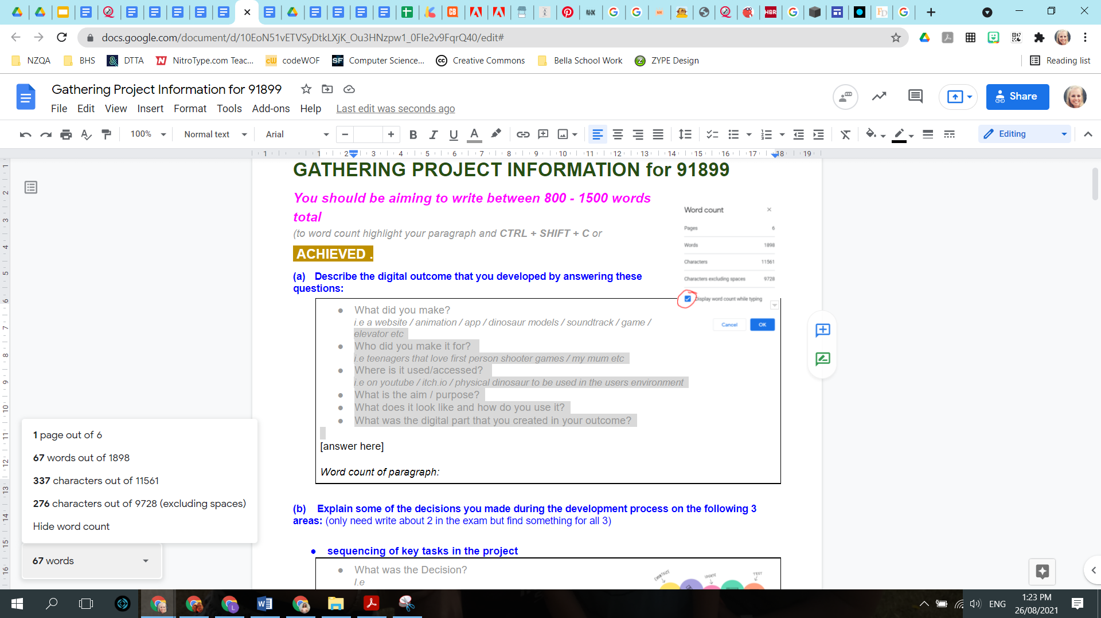

**Helpful tip:** When writing your answers, **bold** any words that link to the question and make it obvious especially things like what the decision was, implication or convention, as well as any sort of judgement that was made by you/stakeholder/client/end-user.

## ACHIEVED .

### (a) Describe the digital outcome that you developed:

|  |
| --- |
| * What did you make? Include the aim / purpose.   *i.e a portfolio website / a portfolio website & all the content / farm animation / study app / dinosaur models / soundtrack for x / 2D platform Christmas game / an elevator / graphics etc*   * Who did you make it for?   *i.e teenagers that love first person shooter games / my mum etc*   * Where is it used/accessed?   *i.e on youtube / itch.io / physical dinosaur to be used in the users environment*   * What does it look like and how do you use it?   *For how you use it….. The keys to move a player / a menu with options / if you have to open something / roll dice, pick up cards or objects / put pieces together to build / if a video push play and watch etc*  *Answer Below*  The outcome I designed and developed was an event page web app showcasing the 2023 Extravaganza occurred in St. Kentigern College. This web app is designed to a wide range of audience, from kids and teenagers that enjoy the absorbing interactions, to adults that seek detailed information, and even elderlies that can navigate the web smoothly. The web can be presented in all sorts of web browsers since it is in html & css, and The actual code is pushed to Github. A simple navigation bar is provided for the user to navigate through the home page, calendar page, detail pages (food, tech, product, fashion etc.). Home page consists of video montage and brief for event; calendar page has customisable calendar for user; Detail pages consists of images, videos and details of each individual work in the exhibit.  *Word count of paragraph: 138* |

|  |
| --- |
| * What was the digital part that you created in your outcome?   *i.e I specifically created all the content used on the website and put the website together using a template from Wix / I specifically created all the plane models for the game / I specifically coded all the x in the game / I created all aspects of the animation myself including the 3d models and the frames / I created the fusion360 working files which I used the animation tool to create a 3D exploded view of the model and I also exported each part to be 3D printed/laser cut to then create the physical product etc*  *Answer Below*  The digital part of my outcome I created was the main structure and components of the web app.  After prototyping my outcome in Figma (prototyping app), I replicated the idea with html, css, (java) and consists of (2) color theme for user to choose. These components are crucial for building a bone structure for further information and non-original components included.  *Word count of paragraph: 60* |

**STEP UP: Explain = *make an idea clear by describing it in more detail by giving a reason - the ‘why’.***

### (b) Explain some of the decisions you made during the development process relating to any of the following: (you normally only need write about 2 in the exam but for this task find something for 3)

* **the design process**
* **the project-management process**
* **the choice of tools, and techniques for using them**
* **consultation with subject-matter experts**
* **testing and trialling with particular people or groups.**

**Some examples to help -**

|  |  |
| --- | --- |
| **Decision** | **Explain** |
| *Design Process*  *I decided to work through the* ***design thinking*** *approach by following the process of Inquiry, Design, Development, Outcome…. * [follow with the explain].* | *Elaborate on what happened in the different phases. Inquiry allowed you to find out more about x and understand x better. That meant you were able to be quite specific when it came to the requirements and specifications and what the end user needed. Give the example - What was something you found out and the requirement that came from that knowledge.*  *Or something you went in thinking you were going to do x but because of this research you changed it etc*  *By creating a design you got what sort of feedback and that meant you knew what doing into the development.*  *etc* |
| *Project management Process*  *Within (design and) development I followed an* ***Agile Development Process*** *which included the key tasks / milestones of….. [explain]*  ***Iterative process*** *that included* ***sprints****….. [explain]* | *explain how many sprints you had, how you managed this (by using an online tool and checking in). You could give a quick overall of what the general aim was for each sprint and then give some specific details about one in particular….. What the tasks were, what you made and the the testing and feedback you received* |
| *Tools & Techniques*  *What Software did you use? Photoshop/Gimp, Unity, Repl.it Blender etc*  *What specific tools did it have that you used? AND how did you go about using them? There are lots of ways to use certain tools to create your outcome efficiently* | *There are so many tools you use. Work out what tools really allowed you to have an efficient / streamlined experience in the software. You select tools and use techniques (a way of carrying out a particular task) to create your outcome. Think about something you can do multiple ways but one way is a lot faster or a lot less steps. Give a specific example of a tool/s and the technique you went through. What were your go to’s?* |
| *Experts*  *Who was the expert and for what - Mr Rodkiss, expert in game development, Mrs Maddaford, design expert etc*  *It could also be a classmate who is an expert in software or how to use the 3D printers or someone outside of school like a parent or industry expert* | *What did you show these experts and get their opinion on? What did they advise and what did you do? Again specific details. Who are they, what are they an expert in, how did it come about, what is the specifics of the consultation.* |
| *Test & Trialing*  *What testing and trailing did you do with who*  *Using the* ***Usability testing*** *method when developing my xxxx…..* | *You were trying to find out How (useful) your outcome is? Does it do what the end user wants? How do you know?*  *The Usability testing method - most of you would have used* ***in-person testing*** *(vs remote) to conduct* ***usability testing****. This is with a specific group based on your end users and the main goals are to:*  *~ #1 Identify problems in the design of the product*  *~ #2 Uncover opportunities to improve*  *~ #3 Learning about the target user’s behavior and preferences* [*https://www.nngroup.com/articles/usability-testing-101/*](https://www.nngroup.com/articles/usability-testing-101/)  *Give some specific examples* |

|  |
| --- |
| **Decision 1**: **CSS advanced techniques: Media Query & Flexbox** |

|  |
| --- |
| In the CSS code, I have frequently used Flexbox properties and Media Query in most components.  *Word count of paragraph:* |

|  |
| --- |
| **Decision 2**: **Agile Development** |

|  |
| --- |
| I have decided to adapt agile developing: using weeks as 1 period of sprint and record my progress in Trello (workspace). This decision keeps my progress on track and  *Word count of paragraph:* |

|  |
| --- |
| **Decision 3**: **External tools: Figma, Github, VSCode Extenions** |

|  |
| --- |
| To  *Word count of paragraph:* |

## MERIT .

**STEP UP: Discuss = talk or write about (a topic) in detail, taking into account different issues or ideas.** Think about what you wrote when you described your outcome in the very first question and how you could elaborate on some of those areas.

Imagine having a conversation with someone like your teacher when writing these answers

### Discuss how the digital outcome addressed relevant requirements (at least 2)

### Easiest options to use…..

* Needs to fully function as a [game, app, website, model dinosaur etc]
* Needs to be easy to use
* Needs to follow suitable conventions
* Needs to look aesthetically pleasing

***You can then discuss***

* main character/s / enemies etc
* How it looks like a theme i.e horror
* How its suitable for a specific age group
* Including conventions like navigation bars, menus etc
* How it is fun / entertaining / professional / high quality etc

|  |
| --- |
| **Requirement #1**: **[state the requirement - think back to your proposal]** |

|  |
| --- |
| * State the requirement * Why was this requirement important to your outcome * How did your outcome meet this requirement - make sure you talk about the outcome from the end user perspective and the software end including the digital component where possible * Give specific examples (think about the specifications that relate to the requirement) * Link to conventions, testing, feedback etc. and give specific information about what eventuated and the specific decisions that were made.   *Answer Below*  The **most important requirement** of my [your outcome] was……  *Word count of paragraph:* |

|  |
| --- |
| **Requirement #2**: **[state the requirement - think back to your proposal]** |

|  |
| --- |
| * State the requirement * Why was this requirement important to your outcome * How did your outcome meet this requirement - make sure you talk about the outcome from the end user perspective and the software end including the digital component where possible * Give specific examples (think about the specifications that relate to the requirement) * Link to conventions, testing, feedback etc. and give specific information about what eventuated and the specific decisions that were made.   *Answer Below*  Another **important requirement** of my [your outcome] was……  *Word count of paragraph:* |

|  |
| --- |
| **(optional) Requirement #3**: **[state the requirement - think back to your proposal]** |

|  |
| --- |
| * State the requirement * Why was this requirement important to your outcome * How did your outcome meet this requirement - make sure you talk about the outcome from the end user perspective and the software end including the digital component where possible * Give specific examples (think about the specifications that relate to the requirement) * Link to conventions, testing, feedback etc. and give specific information about what eventuated and the specific decisions that were made.   *Answer Below*  Another **important requirement** of my [your outcome] was……  *Word count of paragraph:* |

### Discuss how the digital outcome addressed relevant implications (only need write about 2 in the exam)

* **legal issues**
* **future-proofing**
* **the needs of end users.**

|  |
| --- |
| **Implication #1**: **[state the implication]** |

|  |
| --- |
| * State the relevant implication * Why was this implication important to the project * How did your project meet this implication * Give specific examples and information about what happened and the decisions that were made. * What does this now mean? * **make sure it is something different to what you have written in requirements DO NOT REPEAT**   *Answer Below*  [**Legal Issues / Future Proofing / The needs of the end users]** was an important relevant implication because  *Word count of paragraph:* |

|  |
| --- |
| **Implication #2**: **[state the implication]** |

|  |
| --- |
| * State the relevant implication * Why was this implication important to the project * How did your project meet this implication * Give specific examples and information about what happened and the decisions that were made. * What does this now mean? * **make sure it is something different to what you have written in requirements DO NOT REPEAT**   *Answer Below*  [**Legal Issues / Future Proofing / The needs of the end users]** was an important relevant implication because  *Word count of paragraph:* |

## EXCELLENCE .

**STEP UP: Evaluate = form an idea of the value of; assess it.**

### Evaluate the decisions you made in the development process from the following list

* the design process
* the project-management process
* the choice of tools, and techniques for using them
* consultation with subject-matter experts
* testing and trialling with particular people or groups.
* **Some key reasons for why it was good, the advantage…..** 
  + Finish my xxx on time
  + high quality/professional/polished (etc) outcome
  + performed better than expected
  + End users have a better experience
  + Cheap way to test

**Helpful Tips**: Expand on what you wrote in the achieved and merit questions to easily show the step up. It means you can spend time going into more detail about the digital outcome and how you have worked through a process/ created it with specific examples

|  |
| --- |
| **Decision 1**: **[copy the bullet point from the early question (seen in b) or talk about something else]** |

|  |
| --- |
| * What was the decision you made during your development process * Was this decision a good one? *(try and use good decisions as the ‘bad’ ones may be useful as things to improve on)* * What the advantage was * Why it was good / How did this impact/affect your outcome   + make links between the outcome, materials / tools / software / testing / feedback that was selected / used and the performance and / or quality of the outcome.   + go into more detail about the digital aspect and how you had created it with specific examples   [answer here]  *Word count of paragraph:* |

### 

|  |
| --- |
| **Decision 2**: **[copy the bullet point from the early question or talk about something else]** |

|  |
| --- |
| * What was the decision you made during your development process * Was this decision a good one? *(try and use good decisions as the ‘bad’ ones may be useful as things to improve on)* * What the advantage was * Why it was good / How did this impact/affect your outcome   + make links between the outcome, materials / tools / software / testing / feedback that was selected / used and the performance and / or quality of the outcome.   + go into more detail about the digital aspect and how you had created it with specific examples   [answer here]  *Word count of paragraph:* |

### 

### Discuss what you could have done differently in the development process and how this would improve the outcome.

### (a) Improvement #1

|  |
| --- |
| * What was the (one) aspect that you could have done differently during your development process *(needs to be different from what is above so think about something that wasn’t as successful as you thought it would be)* * How did this impact/affect your outcome (What should it have done and what actually happened)   + make links between the outcome, materials / tools / software / testing / feedback that was selected / used and the performance and / or quality of the outcome.   + go into more detail about the digital outcome and how you had created it with specific examples * What would you do differently now AND how would this improve your outcome   [answer here]  *Word count of paragraph:* |

### 

### (b) Improvement #2

|  |
| --- |
| * What was the (one) aspect that you could have done differently during your development process *(needs to be different from what is above so think about something that wasn’t as successful as you thought it would be)* * How did this impact/affect your outcome (What should it have done and what actually happened)   + make links between the outcome, materials / tools / software / testing / feedback that was selected / used and the performance and / or quality of the outcome.   + go into more detail about the digital outcome and how you had created it with specific examples * What would you do differently now AND how would this improve your outcome   [answer here]  *Word count of paragraph:* |

### 

**MY TOTAL WORD COUNT:**